|  |  |
| --- | --- |
| **Ex.No:10** | **Word Count in Command Line Arguments** |
|  |

***Aim:***

To develop a python program that performs word count in command line arguments.

***Algorithm:***

|  |  |
| --- | --- |
| **Step 1:** | Start Process |
| **Step 2:** | Read commands from system |
| **Step 3:** | Store in args list |
| **Step 4:** | Initialize count with 0 |
| **Step 5:** | Read next command from args |
| **Step 6:** | Print command and increase count |
| **Step 7:** | If args has next command goto Step 5 |
| **Step 8:** | Else display count |
| **Step 9** | Stop Process |

**Flow Chart:**

**Pseudo Code Prime Finder:**

START

READ args from system stream

ASSIGN count = 0

WHILE args has commands THEN

READ command

PRINT command

INCREMENT count

END WHILE

PRINT count

STOP

**Program:**

import sys

args = sys.argv

count = 0

for command in args:

print (command)

count+=1

print ("Total number of arguments:",count)

input("Thanks")

**Output:**

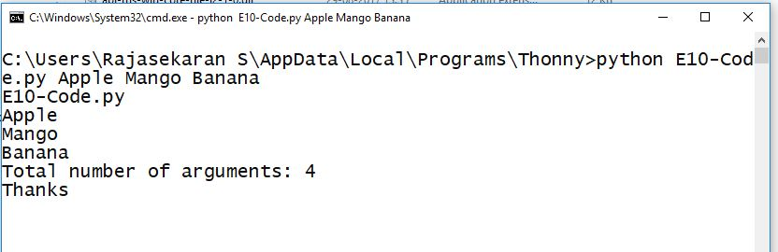

***Result:***

Thus the python program that performs word count in command line arguments was developed and tested successfully.